European Solidarity Corps Project:
Youthquake II
Resilience Paths
2020-3-IT03-ESC11-020676

Activity: Mozzi-Borgetti Library and Nursery Schools
Period: May 2022 – November/December 2022 (6 months)
Where: Macerata: Mozzi-Borgetti Library and Nursery Schools
Topic: Culture, Community Development
Coordinating organization: ARCS Arci Culture Solidali APS
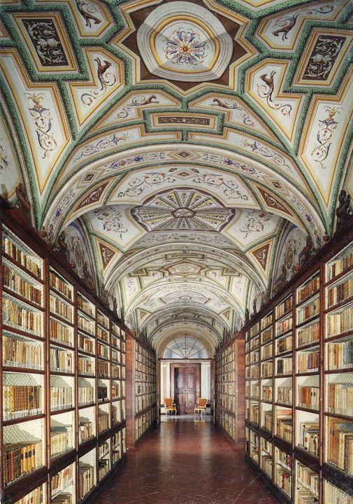
Hosting Organization: Municipality of Macerata
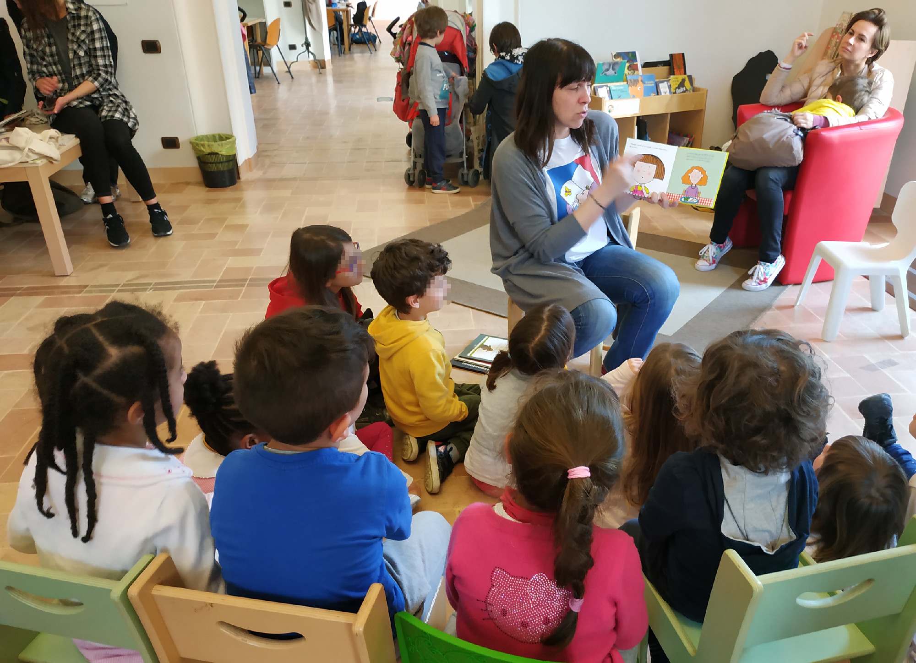

What is Youthquake II ?
The ESC project Youthquake II, stems from the desire to follow up on the relationships consolidated during the first edition of the strategic volunteering project Youthquake (2017-2020) by building active and solidarity-based responses to the new social challenges born also as a result of the covid19 emergency. The solidarity experiences represent an important example of non-formal learning both for the young beneficiaries of the experiences but also for the local host communities, as indicated by the Council Recommendations on the mobility of young volunteers in the EU, which will benefit from the presence, commitment and energy of young volunteers from different European countries.
Youthquake II, through the different actions proposed and the involvement of 50 EU volunteers, aims at enhancing the internal and marginal, rural and urban areas of central Italy through concrete actions of solidarity and volunteering in order to promote active citizenship itineraries for young and old inhabitants of those areas, in a local and international perspective. The impact that participation in the activities can have on the participants is linked to the volunteers' personal, civic, social and professional development. Through non-formal and informal learning experiences, volunteers can acquire useful skills that will allow them to chart their own course in society from an educational, human, civic and professional point of view.

Who is ARCS ?
ARCS - NGO association was founded in Rome in 1985 by Arci, the largest secular association for social and cultural promotion in the Italian Third Sector, founded in 1957 in Florence and present throughout the country.
The ARCS action plan in its international cooperation activities consists in the involvement of communities and citizens in the widespread creation of relations and cooperation between territories and communities, through the enhancement of civil aggregations, the building of networks of interest and the strengthening of democratic ownership. For the assertion of peace and human rights and the elimination of all forms of poverty, injustice and social inequality ARCS practices: Education to world citizenship and peace; Cooperation, solidarity and international volunteering; Humanitarian aid and reception.

Who is the Hosting organization?
The city of Macerata (https://www.comune.macerata.it/) is located in the Marche Region, ins Central Italy, and has just over 40.000 inhabitants, 7.329 of which (17.3% of the population) are young people aged from 15 to 30 years old. The Municipality is responsible for the management of its population and territory, including cultural heritage, social services and economic growth. Macerata can boast a rich and active social life thanks to the presence of a University of ancient traditions, an Academy of Arts and more than 150 associations, which enrich the offer of events, from the environment to culture, from entrepreneurship to volunteering. The 2016 earthquake has affected also our Municipality and it is still possible to perceive its effects in terms of housing problem, as well as economic and social ones, which have affected in particular the most vulnerable groups (children, elderly people and people with disabilities).
Among the many associations in Macerata, there is also the ESN Macerata, which offers a wide range of activities for Erasmus students and has declared its willingness to include our EVS volunteers in their activities. The volunteers will then have the opportunity to live in a lively and multicultural context.
Locations of this specific position will be:
- the Mozzi-Borgetti Library (https://www.facebook.com/BibliotecaMozziBorgetti/)
- Local Nursery Schools.
Macerata can boast an medieval city center with many interesting attractions:
- Piazza della Libertà, the mail square, boasting several historical buildings, such as the Civic Tower with the Astonomical Clock, Lauro Rossi Theater, the Loggia dei Mercanti (a Renaissance Loggia) and university buildings.
- many Churches (Macerata Cathedral, San Filippo Neri, Santa Maria della Misericordia etc.)
- the Arena Sferisterio, a big neoclassical arena, hosting concerts and festivals, such as the well-known Macerata Opera Festival, a festival devoted to Opera
- the Mozzi-Borgetti Library, with its magnificent Old Rooms
- Palazzo Buonaccorsi, housing the main civic art museum and a Carriage Museum.
Morever, from Macerata you can easily reach the seaside, as well as the Sibillini Mountains.

In these links below you can find two articles of Aneta, Silvia and Charlotte, our three last amazing volunteers, hosted by Macerata Municipality in 2021:
1 (https://www.facebook.com/informagiovani.macerata/posts/4882182615128063) and 2 ( https://www.facebook.com/informagiovani.macerata/posts/4839069402772718 ), they are in Italian but you can easily translate them with this tool https://www.deepl.com/translator :)

Activity description
The volunteer will be included in the activities of the Mozzi-Borgetti Library.

Activity 1: supporting the employees of the library in the following tasks:
- ideation and realization of educational and entertainment activities (readings aloud in English for children, workshops, guided listening labs, film viewings, books’ presentations, theatre lab etc.)
- support in the online promotion of the library events;
- support in books’ cataloguing and lending;
Activity 2: Realization of activities in the local Nursery Schools of Macerata: reading aloud and interaction in foreign language (possibly English) with babies, with the aim to introduce children to reading and to foster multilingualism.
Activity 3: Italian language classes
Activity 4: Social inclusion: Intercultural activities in partnership with ESN Macerata (if possible, according to the Covid-19 situation).
The volunteers will work max 35/38 hours per week with the availability to work sometimes with turnation in the weekend or in the evening; the volunteers will have 2 free days per week.

Here below an exemplifying weekly schedule:
- 23 hours in Mozzi-Borgetti Library
- 10 hours in the local Nursery Schools
- 2 hours for Italian classes (in the first four months)
- 1 hour with mentor for personal project

This schedule may change during the period. For example, in Summer, when the Nursery Schools are closed (from mid July to the end of August approximately), the volunteer will spend more time in the Mozzi-Borgetti Library. The activities could change also due the pandemic, so some of them could be readapted in online way for some periods. The readaptation of the activities will be shared and discussed with the volunteers in order to create new ways to carry out the values of the proximity and solidarity.

The volunteer will receive a pocket money of 5 euro per day and specific budget for the food allowance of 5 euro per day. The volunteers will be accommodated in a private room in a shared apartment near the city centre. The apartment is fully furnished and equipped with all the necessary utilities: kitchen (with kitchenware and cutlery), bathroom, single bedrooms, heating, Wi-Fi and washing machine. If not already available in the apartment, the volunteer will be provided with a basic kit (one set of linen, one duvet, one set of towel).
The volunteers will be supported in the development of their learning process by a tutor who will organize group or individual meetings. The volunteers who will be included inlong terms experiences (+59 days) will join also the Training courses organized by the Italian National Agency for Youth.

Macerata is quite small and the locations are easily reachable on foot the locations. However, the volunteers will be provided with a monthly lump-sum of 20 €, intended as contribution for local transportation (volunteers can use it to buy single tickets, costing 1,25 € each, or monthly pass, costing 30 €).

Volunteers profile
No specific requisite is needed. However, a degree in Humanities will be valued positively as well as a good knowledge of English and a basic knowledge of Italian.
Volunteers should be interested in working with babies, children and teenagers and ideally have some experiences in this field. They should have strong interpersonal skills, be proactive and adaptable, as well as able to work in an intercultural group.

The project includes: The selection process
- The applicants have to send the candidature only by the ESC Portal, to this link: https://europa.eu/youth/solidarity/placement/26138_en ;
- The applicants will be contacted by ARCS to complete the application. There will be requested an english CV, cover letter and to complete an application form.
- The applicants which profiles will fit better with the project will be contacted by the HO for a skype interview. All will receive a feedback.
- Confirmation 😊

- Trasport tickets roundtrip up to 275 euro
- Food allowance: 5 euro per day
- Pocket money: 5 euro per day
- Italian online language course (OLS)
- Private insurance
- Accomodation in shared home/flat
- Youthpass: the official experience certificate

If you have any question, doubt or curiosity you can contact us to: Arcs.youthquake@gmail.com ; persia@arcsculturesolidali.org

Share the Solidarity through Youthquake II, the amazing ESC world is waiting for you!
